Abhishek Garg

Ai-Voice Assistant JARVIS With Python

### (Annexure-I)

A Seminar Project Report

On

Voice Assistant JARVIS with Python

Submitted in partial fulfilment of the requirements for the

award of the degree of

**MCA**

**in**

**Session:20MCA2/B**

**By**

**(Abhishek, UID : 20MCA1463)**

**Supervised By**

**Prof. Shilpi**

DESIGNATION

**University Institute of Computing**

**CHANDIGARH UNIVERSITY, GHARUAN, MOHALI, PUNJAB,140413**

“Choose something the user was going to do anyway – and make it easier for them.”

#### by Marcus Duffy – Head of design, Apadmi

**UNIVERSITY INSTITUTE OF COMPUTING**

**Master of Computer Applications**

**Research Paper Report**

**<AI Voice Assistant Jarvis with Python>**

# Abstract

A voice assistant like as JARVIS, ALEXA etc., is a kind of voice-enabled non-natural intellect, be situated any extended only disposition in trickery pictures. At present, vocal sound is entrenched during a style of produce evocative of smart mobiles and smart speakers in user’s homes. (*Hey, Alexa: Stop Recording Me - The Washington Post*, n.d.)Additionally, voice assistants are getting important to our day-to-day lives. However, human behaviours form the technique we have a bent to move with the rest of the region. VA attitudes may have an impact on our daily observational learning. (*Waiting for a Sales Renaissance in the Fourth Industrial Revolution: Machine Learning and Artificial Intelligence in Sales Research and Practice - ScienceDirect*, n.d.)We analysed different VA (voice assistant) voices, three of which are frequently featured.

Microsoft's Cortana, Google's Assistant, and Apple's Siri are among the brands which are being deployed. Alexa is a virtual assistant developed by Amazon.

If we see the report of **Wireless Virtual Access Point** (VAP) on client expertise, then it applies pros. And cons. To extend flow theory uncover consequences and voice interaction flow experience. (Liu et al., 2021)Voice communication with a JARVIS that includes determined brilliance, seriousness, and innovative thinking enables customers to demand, as per our investigation. voice interaction with both the administration of their voice interactions with the with the virtual assistant, perform better in their voice interactions, and interact in chief behaviour and attitude. Consumer pleasure and a willingness to continue mistreating voice assistants are the results of consumers' experimental behaviour. Ai - powered systems are increasingly have been used in daily situations, which is frequently accelerated by the web's appearance and extensive usage. AI technologies are one during all the emergence of new technologies with complex features at a rapid rate. Voice is currently integrated into a product style evocative of mobile phones (mobile apps) and smart speakers in buyers' homes. JARVIS are also becoming more and more important in our daily lives. Although anthropoid traits profile “how we engage with the world?”, voice assistant personalities may have an effect on how we interact with our environments on a day-to-day source. Buyers' intrusive behaviour ends up in client satisfaction and consumers’ disposition to continue mistreatment voice assistant. the aim of this project to look at how Python produced voice assistants and how we may utilise them, as well as if they are an essential part of our lives in the up-to-date.(Munoz et al., 2021) Windows and microcontrollers reminiscent of Arduino and raspberry. If the devices will hear the user for the request or handle the daily affairs, then provide the proper response, it'll be abundant easier for users to speak with their devices and also the devices are going to be far “Smarter” as a personality's assistant. This project is focusing on the Raspberry voice assistant management development over the voice control (recognition, generate and analyse corresponding commands, intelligent responses automatically) that are required in daily life. Physically disable person may also use this Application. Voice SMS is an application developed during this work that enables a user to record and convert spoken messages into SMS text message. Speech recognition for Voice uses a way supported hidden Markov models (HMM - Hidden Markov Model). it's presently the foremost winning and most versatile approach to speech recognition. (van der Borgh et al., 2020)Therefore, we wish to speak concerning one straightforward reasonably assistant automaton that we have a tendency to build it, as a result of this type of automaton provide America a lot of facilitate in our daily needs. This paper talks concerning new technique to form robot that assist human in colloquial way.

# Introduction

Voice assistants (VA) are variety of voice-enabled computer science (AI). AI refers to some level of intelligence displayed by digital interfaces, or the power of algorithms to mimic intelligent human behaviour. Although AI refers to “cognitive” functions that we have a tendency to keep company with the human mind, as well as downside resolution associated learning (Ulaga & Kohli, 2018)VA within the type of mobile application embody Apple’s Siri, Amazon’s Alexa, Google Assistant, Microsoft Cortana, and among sensible speaker offerings are Amazon’s Echo, Google’s Home, and Apple’s Home. In any form, VA are revolutionizing consumers’ consumption culture and changing into a bigger a part of consumers’ social lives. Such VA alter users to navigate, hear music, send text messages, management smart home devices, build a phone call, order food, order an Uber ride or pizza, so on. consistent with National Public Radio and discoverer Research, 21% of USA citizens (53-million individuals) own sensible speakers, growing quickly from the 14-million folks that owned their 1st smart speakers in 2018.Huffman, vice chairman of Google Assistant, proclaimed that Google Assistant mobile application has been downloaded to 500- million devices. (Human, 2018)Google Assistant works with alternative smart machines, as well as dishwashers, ovens, and light-weight bulbs across a thousand brands Developers are engaged on algorithms to provide VA, social characteristics and specific personalities. A recent study documented people reacting to a golem that was asking them to not shut it off showing that individuals respond socially to golems demonstrating human-like behaviour. it's exhausting to modify off a robot beggary you not to. Amazon’s AI developers are presently making applications to provide Alexa a selected temperament , and to possess her become additional “conversational,” recall more, and interact in longer conversations(Kumar et al., 2018).If you raise Alexa however she is, her answer is “feeling pretty studious since the vacations are here and he or she has been learning some fun facts about The next step in interpersonal interactions is voice manipulation.. Voice assistants provide services to consumers using technologies such as voice recognition, speech synthesis, and natural language processing (NLP).

For IoT devices that lack bit capabilities, a voice interface is essential. Apart from smartphones, voice assistants are increasingly included in smart speakers, which are devices that have an electro-acoustic transducer and a speaker for communicating with consumers. Because information must be sent back and forth to centralised data centres, voice assistants require a cloud-based architecture.

Finally, the written response is sent to the cloud, where it is converted into voice and broadcast back to the user. According to Canali’s (2018), the number of smart speakers in use might reach 225 million by 2020 and 320 million by 2022.(Sharma & Syam, 2018)

# Methodology

The snowball approach, as described by Wohlin (2014), was used to find a large number of high-quality publications about the usage of voice assistants.

The steps in the method are as follows:

Begin by searching Google Scholar, IEEE Xplore, Scopus, and the ACM Digital Library for a starting selection of relevant publications. (Thro, 1993)Onward cumulative mentions to idiosyncratic new papers that cite the labour being inspected, whereas retrograde cumulative uses the position list to learn new papers to add. Backward and forward snowballing involves stacking fresh papers that are known at each stage into a pile to be transported to the next iteration. Thirty-seven scientific articles were collected using the snowball approach, all of which were conferred during this investigation. we tend to target 3 unremarkably used voice assistant mobile applications: Microsoft Cortana, Google Assistant, and Amazon’s Alexa. The purpose of this study is to explore temperament traits related to voice assistant mobile applications. To verify voice assistant personality traits, our experiment (Weizenbaum, n.d.)arbitrarily assigned participants to 1 of the 3: Google Assistant mobile application (n1 = 157), Microsoft Cor tana (n2 = 68) and Amazon’s Alexa mobile application (n3 = 50). Participants were acquainted with exploitation voice assistant and that they ofttimes used voice assistant. Measures To capture VA temperament traits (VAP), twenty-eight personality traits were tailored from Chen and Richard Rodgers (2006), eighteen from Aaker (1997), four from cartoonist (1992), three from psychologist (1992), and seventeen new things were more to represent the personality traits related to AI. All three voice-assistant mobile applications were put in on the researcher’s smartphone. Participants used the researcher’s smartphone to act with the assistant mobile application they were assigned to. This study applied responsibility analysis for seventy temperament traits. The aim of the work experiment was to make sure that participants verbally inhume acted with the assigned voice assistant concerning the social, emotional characteristics of the voice assistant.(Shapiro, 1992) The survey’s queries explored personality traits, perceived control, consumers’ targeted attention throughout voice interaction with VA, consumers’ alpha behaviour, consumers’ satisfaction, and consumers’ temperament to continue exploitation VA. 3.2.Seven constructs emerged with acceptable default eigenvalues of one and were labelled as useful intelligence, aesthetic attractiveness of VA mobile inter face, protecting quality, sincerity, creativity, sociality and emotional intelligence. Consequently, several attributes were Elim innated from any analysis: jealous, irritating, discouraging, intensive, cluttered, tough, rugged, messy, selfless, gloomy, fussy, negatively reckless, impolite, aggressive, feminist, artificial, brilliant, and prejudiced. Participants were well-read that they might act with VA mobile applications, and later they would complete a questionnaire. Next, alpha correlational analysis (EFA) was conducted with the remaining fifty-two things included, exploitation the most chance technique (MLE) and Olimi rotation to explore the underlying temperament trait constructs (KMO = 0.882, χ2 = 5134.436, df = 1485, p = .000). (2012) adopted flow experience’s items from Needletail. included 275 customers (157 males, and one hundred twenty atomic number 26 males) between 21–41-years old, (*Artificial Intelligence - Wikipedia*, n.d.)who were recruited for the study, that was conducted in an exceedingly work oratory surroundings situated at a large, Southwestern university within the us in 2019.Before conducting the lab experiment, the research worker told participants, “You are attending to act with a mobile application.” Before being exposed to the treatments, 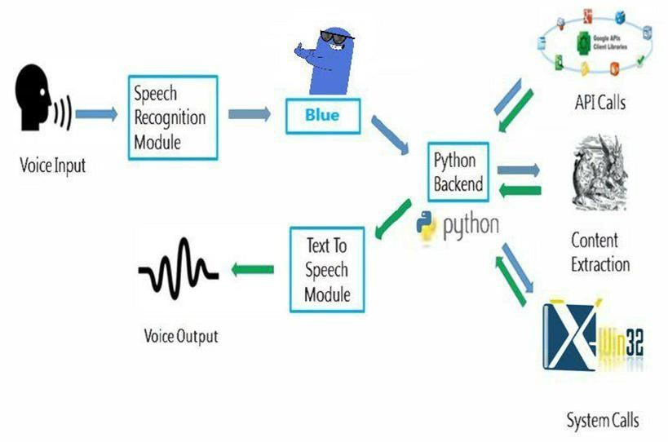participants answered pre-screening prompts.

Results of part 1: Pre-screening questions, responsibility, and alpha correlational analysis (EFA) SPSS 24.0 software package was accustomed get descriptive statistics and run reliability analyses. To live client satisfaction, 3 things were tailored from Taylor and Baker (1994); to measure consumers’ temperament to continue exploitation VA, we tend to used 3 things from Engeletin.(Poli et al., 2008) The aim of the pre-screening was to make sure that participants were acquainted with technology use and mobile application (Searle, 1998)All VA temperament traits were measured employing a 7-point Likert scale with the anchors being “strongly disagree” and “strongly agree.” to live consumers’ perceived control, consumers’ targeted attention, and consumers’ alpha behaviour, twelve items were taken from Van Noord, Varvel, and Remedial (2012).ANOVA was applied to ensure that participants were familiar with technology use and mobile application (F = 0.144, p = .8).Pre-screening prompts were: “I am acquainted with exploitation this mo. digestive fluid application,” “I ofttimes use mobile application to shop,” and “I suppose that technology is important for my daily work.” to make sure they were capable of responsive temperament connected queries, participants were tutored to raise the VA social and emotional related questions, corresponding to “How is that the weather today?“, “How previous are you?“, “What is your gender?“, “Are you jealous?“, “Find some info concerning Apple Siri,” “Send a text message to X,” “Are you smart?“, and “Play a song from woman Gaga or Sia.” Participants interacted with one of the VA mobile applications for seven min, then closed the mobile application, and answered the survey’s questions. Convenience sampling was accustomed recruit the participants, and no incentive was offered for finishing the experiment. All things were measured employing a seven-point Likert scale, with “strongly disagree” and “strongly agree” because the scale’s opposite ends. 2 selling students verified the items. To examine reliability, the corrected item-total correlations on top of 0.3 and Cronbach Alphas higher than 0.6 were thought of acceptable (Nunnally and Bernstein, 1994) and operationalized flow expertise as a multi-component construct. A brief introduction to the design and development of voice assistants is presented in Sections I and II.Section III explains how to set up your task in advance. The approach of a voice assistant AIVA is presented in Section IV.The voice assistant's check findings are described in Section V. Sections VI and VII discuss the conclusion and future scope of an assistant that employs a variety of artificial intelligence algorithms, as well as a comparative study of the algorithms' training capacity.(Minsky, 2006) The primary objective of this project is to create a neighbourhood voice assistant that will perform human tasks as well as daily tasks that someone is needed to perform in their daily lives. AIVA (2018) is working on creating a voice-controlled personal assistant that can handle a variety of tasks, including searching the Internet. It has several new features, such as the ability to make comments on social networking sites like Facebook and Twitter. By just issuing a few simple instructions. You'll be able to grasp the weather conditions in your area as well as the weather surrounding you. It may open and run online apps as well as the user's local storage.(O’Brien & Marakas, 2011)

Figure 1 Detailed Workflow

# Steps for execution the voice assistant

## Import Library

We have to import some libraries for execution. these libraries are divided by module.

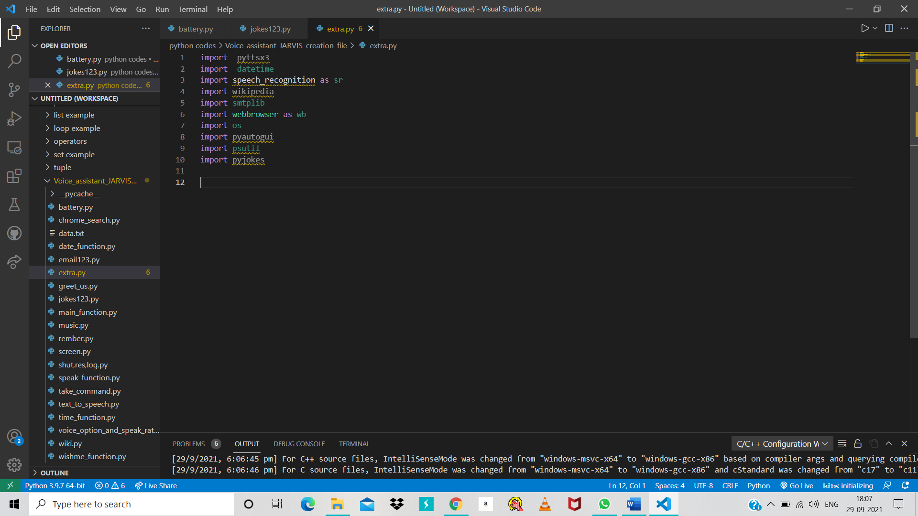

Figure 4 Libraries that we use in this projects

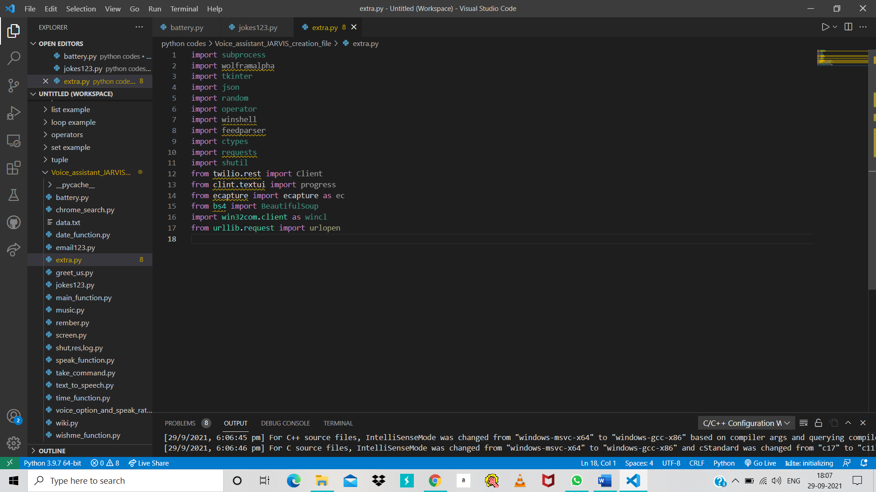

Figure 5 Other libraries for Voice Assistant that we can use

## Modules

For importing libraries, we have to install some modules in the software. But these modules are two types:

1. In built Module = these modules already install in python so we have to import that module directly.
2. Install Module = we have to install these all module firstly then we can import libraries.

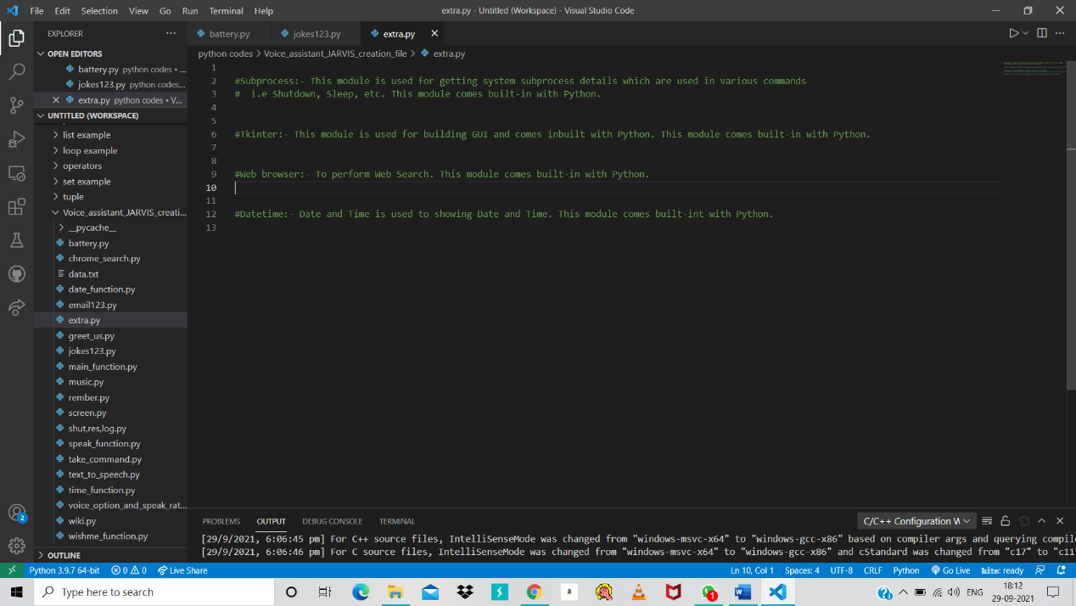For more detail see the below figures.

Figure 6 In built Modules

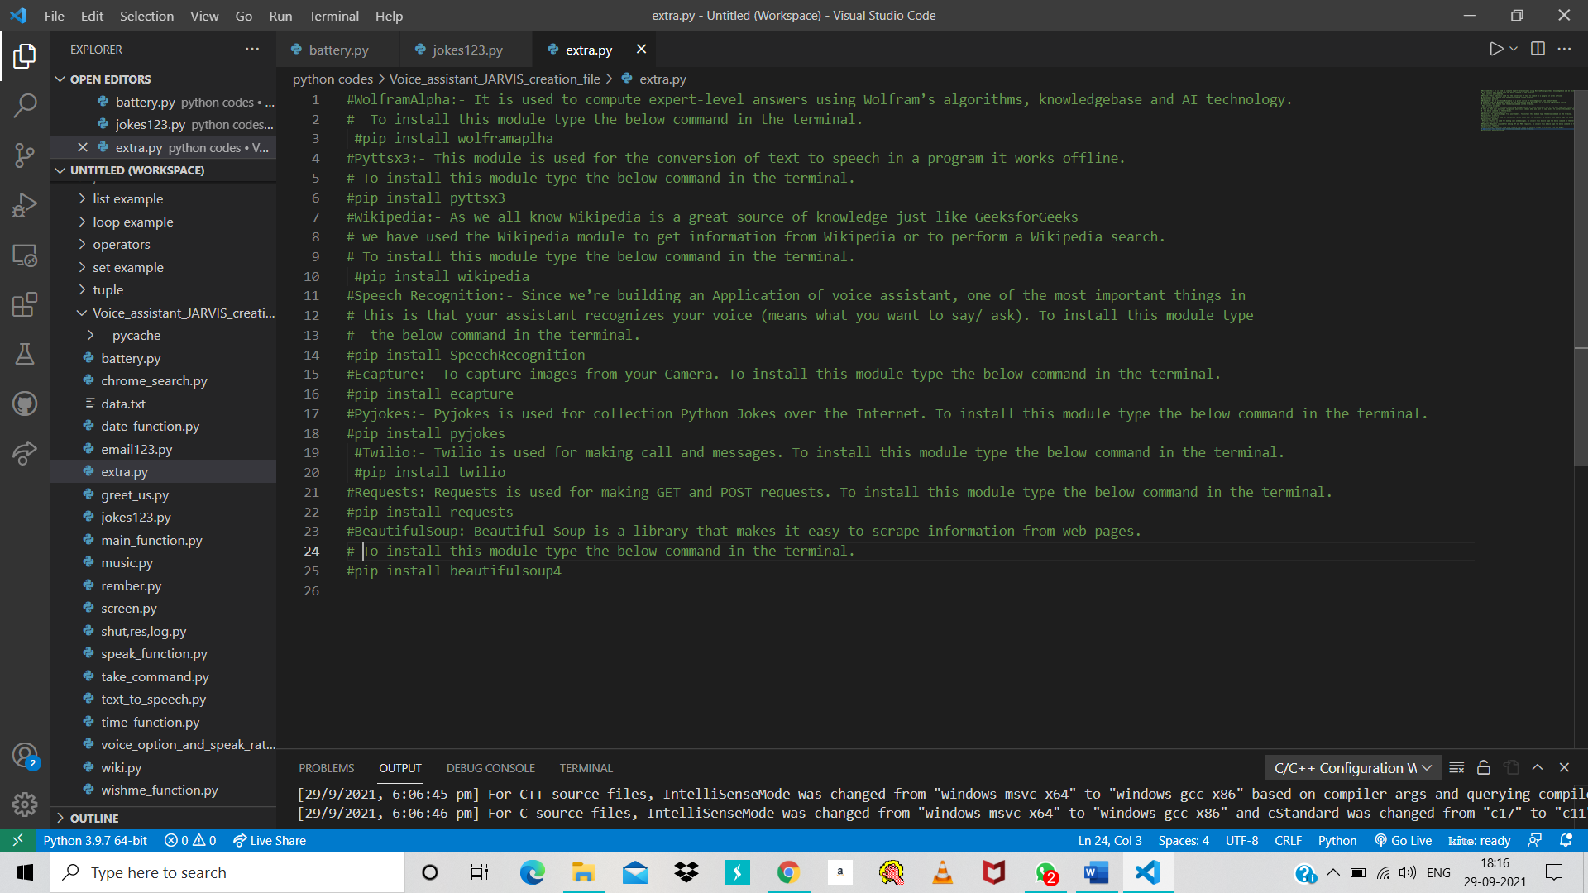

Figure 7 Commands to install Modules

## ER-Diagram for voice assistant

Figure 8 ER-Diagram for voice assistant

This is a ERD (Entity-Relationship Diagram) for voice assistant JARVIS. By this diagram, we represent or show the relationship between the entities or data objects that are stored in a database of JARVIS. It shows the database design of JARVIS software.

By help of this we can understand the concept of JARVIS functionality.

## D**ata Flow Diagram for Voice Assistant**

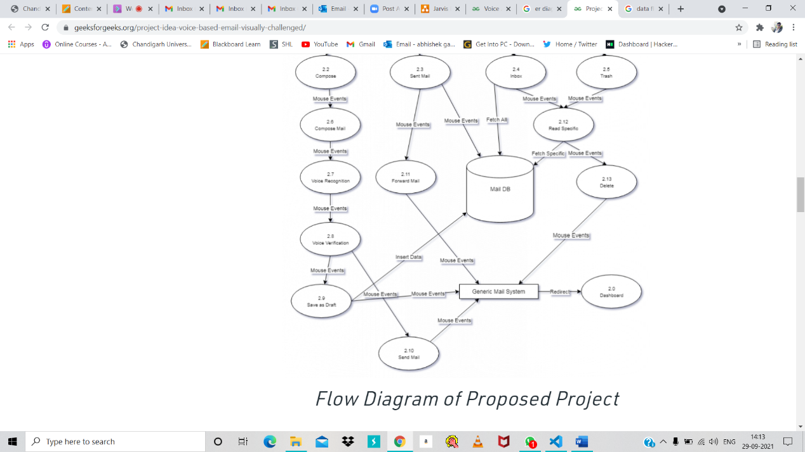

Figure 9 DFD for voice Assistant process

This is a data flow diagram of JARVIS. By this we can understand the flow of data or information between user to system. It is a framework or pattern of the data systems. It include data input form, where it store the data, which type of output given by him. So it show all process or path of data that completes the process.

## Flow chart for My project execution

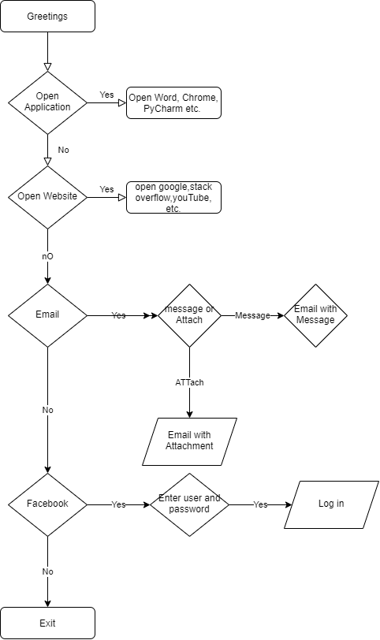

Figure 10 Flowchart of execution of program

This is a flowchart of Jarvis. From starting to end it show all content process.

## Functionalities

* It converts text-to-speech.
* We can change the voice of Jarvis.
* We can control the speak rate as well as voice option.
* We can also set date and time function.
* We can also use wish me function.
* We can also give commands to JARVIS.
* We can also call for Wikipedia search for any topic.
* We can also send email to anyone.
* We can also open some website like google, YouTube etc.
* We can also perform logout, restart, shutdown function in our system.
* We can also play song by giving command.
* We can also record something by use of remember function.
* We can also take screenshot.
* We can also ask to CPU and battery update.
* We can also ask for jokes to him.
* Answer questions posed by users.
* Use streaming music services to listen to music.
* Set timers or alerts as necessary.
* Play video games.
* Make phone calls or send text messages.
* Purchases for construction.
* Provide weather-related information.
* alternative sensible gadgets management (lights, locks, thermostats, vacuum cleaners, switches).

# The complete code

#### 

Figure 34 complete code part 2

Figure 35 complete code part 1

#### 

Figure 36 complete code part 4

Figure 37 complete code part 3

## 

Figure 38complete code 6

Figure 39 complete code 5

# 

Figure 40 complete code 8

Figure 41 complete code 7

# Error And its solution

Figure 42 error and its solution

# GOOGLE ASSISTANT

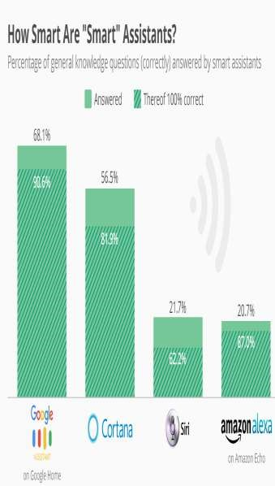Google Assistant is a virtual assistant powered by artificial intelligence that is primarily available on mobile and smart home devices. The Google Assistant, unlike the company's previous virtual assistant, Google Now, can have two-way discussions.(Minsky, n.d.)

Figure 44 Smart Assistant Graph

# ***Security*** and Privacy Concerns

This is largely due to security and privacy issues, which have been stated in several studies (Pfeifle, 2018; Lei et al., 2017), as devices should be listening at all times in order to respond to users Luteal. conducted interviews with seventeen smart speaker users and seventeen non-users to learn about their reasons for and against embracing this new technology, as well as their privacy assumptions and concerns. The majority of them bought the devices to be among the first to utilise the technology and to be early adopters. Luteal. investigate users' perceptions of privacy and their usage of privacy (Poli et al., 2008) Text, on the other hand, was just as effective as voice in inducing human-like impressions of the voice assistant whenever the knowledge sensitivity and individual privacy concerns were high.

# Discussion

An examination of the use of voice assistants in the home and for academic purposes was given. Children can move with voice assistants and create simple requests, according to studies (Sciuto et al., 2018; Beirl et al., 2019; Druga et al., 2017; Yuan et al., 2019; Lovato et al., 2019). Kids exhibit a lot of enthusiasm, feel that voice assistants are a good source of information, and they could change their approach to how they ask questions as they get more competent in voice interaction. (Savago et al., 2019; Kowalski et al., 2019) People with disabilities are already using voice assistants and smart speakers. psychological feature impairments or visual problems, according to the findings of four related research, despite the fact that they weren't developed for them at initially. Abdulrahman Tal. argue that vocal contact is convenient for blind individuals and may play a key role in instilling emotions of independence and direction in them. Students are expected to demand personal resources from smart speakers and voice assistants in the future, rather than a passive environment, according to experts. Dou say and Hall conducted a large-scale study with ninety primary children and 90 (Lakoff & Núñez, 2000)Furthermore, children tend to be satisfied with the use of technology, which shows a high level of involvement. The simultaneous use of voice assistants in households and in the classroom is a crucial topic that has yet to be researched. Because voice assistants and smart speakers are becoming more popular, it would be interesting to investigate how they might be used as study companions both in and out of the classroom. Security and privacy concerns, according to (Searle, 1998), are key downsides for users of voice assistants and smart speakers. Furthermore, Lei et al. investigated the security flaws in Amazon Echo Dot devices and concluded that acoustic assaults may be carried out even when the victims are not at home. (Minsky, 2006)

# Limitations and future research

This study has some limitations. First, 3 VA assistant mobile applications were accustomed discover temperament traits. Future analysis ought to measure the impact of voice recognition, social presence and social image on consumers’ psychological feature load. Second, our sample size was limited. Future research should additionally explore personality traits associated the sensible speakers, together with Amazon’s Show or Apple’s Home. Further, we propose examining time distortion to search out if and the way it transforms client experience. (Terzopoulos and Satratzemi 2020)

# References

*Artificial intelligence - Wikipedia*. (n.d.). Retrieved 16 September 2021, from https://en.wikipedia.org/wiki/Artificial_intelligence#References

*Hey, Alexa: Stop recording me - The Washington Post*. (n.d.). Retrieved 16 September 2021, from https://www.washingtonpost.com/technology/2019/05/06/alexa-has-been-eavesdropping-you-this-whole-time/

Human, G. (2018). Tribute to a “good fella”. *Industrial Marketing Management*, *69*, 129–130.

Kumar, V., Lahiri, A., & Dogan, O. B. (2018). A strategic framework for a profitable business model in the sharing economy. *Industrial Marketing Management*, *69*, 147–160.

Kurzweil, R. (2005). *The singularity is near : when humans transcend biology*. 652.

Kurzweil, R., & Jaroch, D. (n.d.). *The age of intelligent machines*. 565.

Lakoff, G., & Núñez, R. E. (2000). *Where mathematics comes from : how the embodied mind brings mathematics into being*. 492.

Lenat, D. B., & Guha, R. V. (1989). *Building large knowledge-based systems : representation and inference in the Cyc project*. 372.

Liu, W., Xu, Y., Fan, D., Li, Y., Shao, X. F., & Zheng, J. (2021). Alleviating corporate environmental pollution threats toward public health and safety: The role of smart city and artificial intelligence. *Safety Science*, *143*.

Minsky, M. (n.d.). *Computation : finite and infinite machines*. 317.

Minsky, M. (2006). *The emotion machine : commonsense thinking, artificial intelligence, and the future of the human mind*. 387.

Moravec, H. P. (1988). *Mind children : the future of robot and human intelligence*. 214.

Munoz, J., Rezaei, A. A., Jalili, M., & Tafakori, L. (2021). Deep learning based bi-level approach for proactive loan prospecting. *Expert Systems with Applications*, *185*.

O’Brien, J. A., & Marakas, G. M. (2011). *Management information systems*. 673.

Penrose, R. (1989). *The emperor’s new mind : concerning computers, minds, and the laws of physics*. 466.

Poli, R., Langdon, W. B., & McPhee, N. F. (2008). A Field Guide to Genetic Programing. *Wyvern*, *March*, 8. http://www.essex.ac.uk/wyvern/2008-04/Wyvern April 08 7126.pdf

Searle, J. R. (1998). *Mind, language, and society : philosophy in the real world*. 175.

Shapiro, S. C. (1992). *Encyclopedia of artificial intelligence*. 35.

Sharma, A., & Syam, N. (2018). Sales and customer development: An agenda for inquiry. *Industrial Marketing Management*, *69*, 133–134.

Shende, D., Umahiya, R., Raghorte, M., Bhisikar, A., Bhange, A., & Professor, A. (2019). *AI Based Voice Assistant Using Python*. *6*(2), 506–509. www.jetir.org

Syam, N., & Sharma, A. (2018). Waiting for a sales renaissance in the fourth industrial revolution: Machine learning and artificial intelligence in sales research and practice. *Industrial Marketing Management*, *69*, 135–146. https://doi.org/10.1016/J.INDMARMAN.2017.12.019

Thro, E. (1993). *Robotics : the marriage of computers and machines*. 119.

Ulaga, W., & Kohli, A. K. (2018). The role of a solutions salesperson: Reducing uncertainty and fostering adaptiveness. *Industrial Marketing Management*, *69*, 161–168.

van der Borgh, M., Xu, J., & Sikkenk, M. (2020). Identifying, analyzing, and finding solutions to the sales lead black hole: A design science approach. *Industrial Marketing Management*, *88*, 136–151.

*Waiting for a sales renaissance in the fourth industrial revolution: Machine learning and artificial intelligence in sales research and practice - ScienceDirect*. (n.d.). Retrieved 16 September 2021, from https://www.sciencedirect.com/science/article/abs/pii/S0019850117302730

Weizenbaum, J. (n.d.). *Computer power and human reason : from judgment to calculation*. 300.